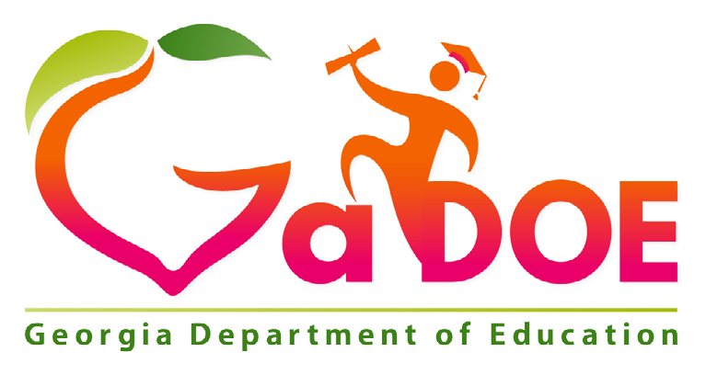

School Improvement Plan
2020-2021
Comprehensive Needs Assessment

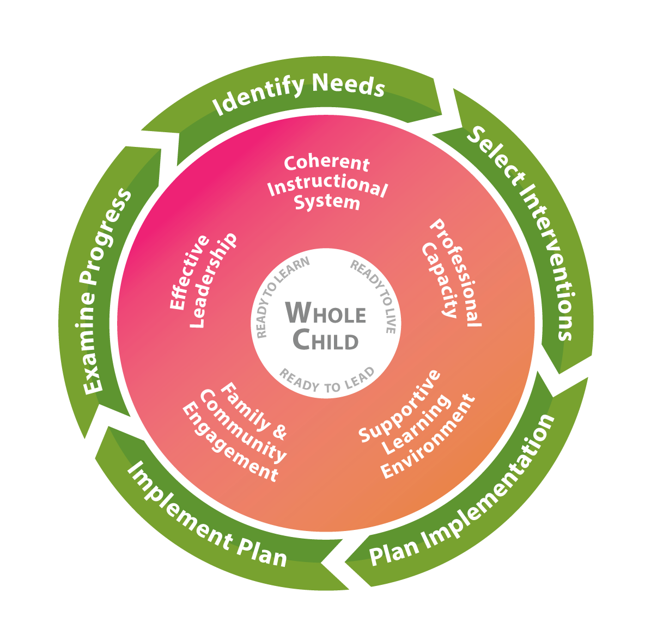

Dowell Elementary School
SUBMITTED:
June 30, 2020
DATE REVISED

1

GEORGIA’S SYSTEMS OF CONTINUOUS IMPROVEMENT
The Georgia Department of Education’s strategic plan emphasizes transforming the agency into one that provides meaningful support to schools and districts. The agency has developed a common, continuous improvement framework to ensure that these efforts are aligned across all agency divisions, departments, and programs. Georgia’s Systems of Continuous Improvement focuses on the systems and structures (the “what”) that must be in place for sustained improvement in student outcomes. It also utilizes a problem-solving model (the “how”) to provide a clear process for identifying improvement needs, planning for improvement, and implementing, monitoring, and evaluating the improvement efforts.
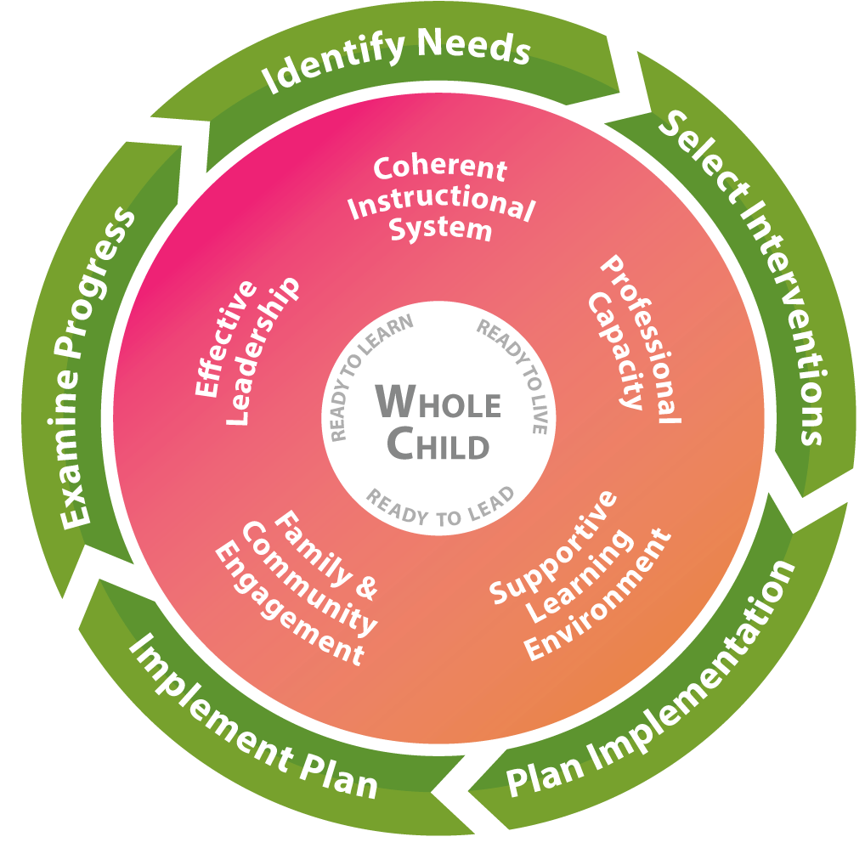
Systems to Improve (What to Improve)
Coherent Instructional System: The major system of the complex school organization that articulates and guides the “what” and “how” of instruction. This comprehensive system includes the processes related to:
- Planning for quality instruction - The structure of the instructional system in which the district defines what the students should “know” and “do”, and determine how their students will show they “know” the content and can “do” a skill or performance task
- Delivering quality instruction - The structure of the instructional system that guides teachers in how they introduce content, practice its use along with the students, and then allow students to use the content on their own while providing students regular standards-based feedback to gain mastery of the content
- Monitoring student progress - The structure of the instructional system that methodically discovers if the students are getting the content, and what to do about it when they are getting it or are not getting it
- Refining the instructional system - The structure of the instructional system that examines how to improve the planning for quality instruction, delivering quality instruction, and monitoring student progress

Georgia’s Systems of Continuous Improvement
Effective Leadership: A major system of the complex school organization that sets the direction for the school, ensures that the school staff and the school leaders are capable of meeting that direction, and makes sure the organization functions according to its mission. This system includes the processes related to:
- Creating and maintaining a climate and culture conducive to learning - the structure of the leadership system that ensures that the school allows both adults and children to put learning at the center of their daily activities
- Cultivating and distributing leadership - the structure of the leadership system that develops others to accomplish the group’s purpose and encourages the development of leadership across the organization
- Ensuring high quality instruction in all classrooms - the structure of the leadership system that reduces the variability in the quality of instruction across all schools and all classrooms
- Managing the district and its resources - the structure of the leadership system that ensures leaders effectively use all the resources at hand so that the district functions according to its mission
- Driving improvement efforts - the structure of the leadership systems that methodically, intentionally, and effectively improves the district’s major systems, structures, and processes
Professional Capacity: A major system of the complex school organization that develops a quality staff to reduce the variance of quality in instruction throughout the school. This system includes the processes related to:
- Attracting staff - the structure of the professional capacity system that is intentional in locating the teachers and leaders that are the best fit for the district and its schools to achieve its mission
- Developing staff - the structure of the professional capacity system that ensures the increasing quality of the school staff’s knowledge and skills
- Retaining staff - the structure of the professional capacity system that ensures the quality staff is working in the context/ position that is most beneficial to student achievement
- Ensuring staff collaboration - the structure of the professional capacity system that reinforces the effective practice of constant collaboration to improve instructional quality in all schools and in all classrooms
Family and Community Engagement: A major system of the complex school organization that develops quality links between school professionals and the parents and community the school is intended to serve. This system includes the processes related to:
- Welcoming all families and the community - The structure of the family and community engagement system that ensures families and the community are active participants in the life of the school, and feel welcomed, valued, and connected to each other, to school staff, and to what students are learning and doing in the school
- Communicating effectively with all families and the community - The structure of the family and community engagement system that ensures families/the community and school staff engage in regular, two-way, meaningful communication about student learning
- Supporting student success - the structure of the family and community engagement system that ensures families, communities, and school staff, continuously collaborate to support students’ learning and healthy development both at home and at school, and have regular opportunities to strengthen their knowledge and skills to do so effectively
- Empowering families - the structure of the family and community engagement system that ensures families are empowered to be advocates for their own and other children, to ensure that students are treated fairly and have access to learning opportunities that will support their success
- Sharing leadership with families and the community - the structure of the family and community engagement system that ensures families/the community and school staff are equal partners in decisions that affect children and families and together inform, influence, and create policies, practices, and programs
- Collaborating with the community - the structure of the family and community engagement system that ensures families and school staff collaborate with community members to connect students, families, and staff to expanded learning opportunities, community services, and civic participation
Georgia’s Systems of Continuous Improvement
Supportive Learning Environment: A major system of the complex school organization that ensures students’ school participation and willingness to expend major effort on classroom learning. This system includes the processes related to:
- Maintaining order and safety - the structure of the supportive learning environment system that ensures that the basic needs of orderliness and safety are met
- Developing and monitoring a system of supports - the structure of the supportive learning environment system that provides comprehensive services to students to meet their unique, whole-child needs
- Ensuring a student learning community - the structure of the supportive learning environment system that ensures compliance with positive and healthy behavioral and academic norms
Process to Improve (How to Improve)
Step 1: Identify Needs: Consult many sources to determine what in the district needs improvement.
- Plan and prepare for the process
- Collect and analyze data
- Identify needs and conduct a root cause analysis
Step 2: Select Interventions: Research many sources to determine the solutions that have a good chance of meeting the identified district needs.
- Consider all the evidence for needed improvements
- Research possible interventions
- Determine if staff has the capacity to implement possible interventions
Step 3: Plan Implementation: Develop a team and plan to implement the solutions that are most promising and can be carried out at the school.
- Identify roles and responsibilities of those implementing the intervention
- Develop a team that will deeply understand the intervention and of best ways to implement it
- Develop the implementation timeline
- Identify resources and supports needed for the implementation of the intervention
- Develop a set of information to be reviewed to track the implementation
Step 4: Implement Plan: Carry out the plan to implement the promising solutions, making real-time adjustments where/ when needed.
- Collect information to monitor the quality of supports being provided for the intervention
- Consider what additional information is needed to determine if intervention is working
- Assess the degree to which the implementation plan is being followed
- Identify ways to break down any barriers
- Build capacity of others to facilitate the improvement process now and in the future
Step 5: Examine Progress: Determine whether the implementation of the promising solutions is meeting the originally identified needs of the school.
- Determine if the staff can formally study the effects of the intervention to share with others in the field
- Monitor implementation and progress against defined goals
- Define reasonable expectations for success
- Identify and track progress and performance
- Develop a plan for how knowledge about the intervention will be shared with others
- Use the evidence to determine whether the intervention should continue as is, be modified, or be discontinued

Georgia’s Systems of Continuous Improvement
Georgia Department of Education
School Improvement Plan
1. GENERAL IMPROVEMENT PLAN INFORMATION
District Name |  |  | Cobb County School District
School Name |  |  | Dowell Elementary School
Team Lead |  |  | Christine Dinizio
Position |  |  | Principal
Email |  |  | Christine.dinizio@cobbk12.org
Phone |  |  | 678-594-8059
Federal Funding Options to Be Employed (SWP Schools) in This Plan
(Select all that apply)
 | X | Traditional funding (all Federal funds budgeted separately)
 |  | Consolidated funds (state/local and federal funds consolidated) - Pilot systems ONLY
 |  | “Fund 400” - Consolidation of Federal funds only
Factor(s) Used by District to Identify Students in Poverty
(Select all that apply)
 | X | Free/Reduced meal applications
 |  | Community Eligibility Program (CEP) - Direct Certification ONLY
 |  | Other (if selected, please describe below)
1. General Improvement Plan Information

2. SCHOOL IMPROVEMENT GOALS

2.1 CREATING IMPROVEMENT GOALS
Effective goals assist schools in attaining collective agreement about what work needs to occur for improvement to take place. Goals should focus and prioritize the efforts and resources of the district/school to the previously identified needs and create a focus for improvement. Setting goals should be a strategic process which aligns the goals within one of the five systems: Coherent Instruction, Effective Leadership, Professional Capacity, Family and Community Engagement, or Supportive Learning Environment.
There are several categories of goals which may be used in school improvement but the one type which focuses on improving results and not just enhancing processes is a SMART goal. SMART is an acronym for:
Specific Measurable Attainable Relevant Time-bound
An example of a SMART goal is:
By the end of the school year 2017-2018, all teachers will have training and be included in a PLC for their content-specific area.

2.1.1 Completing the Improvement Goals Tables
Enter the school’s two to four overarching needs and related root causes, as identified in the Comprehensive Needs Assessment 2017-2018 School Report, into the tables on pages 8, 14, 20, and 26. Determine a goal for each overarching need and include the goal in the last row of each corresponding table. For each overarching need, complete the planning tables covering the five systems from Georgia’s Systems of Continuous Improvement. Use the codes below to list the structures addressed through the goal within each system. For each system, identify one to six action steps that will be taken to address the root causes that have created the overarching need. Finally, identify any supplemental action steps necessary to ensure the necessary supports are in place for the listed subgroups.

Coherent Instructional System
CIS-1 Planning for quality instruction
CIS-2 Delivering quality instruction
CIS-3 Monitoring student progress
CIS-4 Refining the instructional system
Effective Leadership
EL-1 Creating and maintaining a climate and culture conducive to learning
EL-2 Cultivating and distributing leadership
EL-3 Ensuring high quality instruction in all classrooms
EL-4 Managing the district and its resources
EL-5 Driving improvement efforts
Professional Capacity
PC-1 Attracting staff
PC-2 Developing staff
PC-3 Retaining staff
PC-4 Ensuring staff collaboration

2. School Improvement Goals
Family and Community Engagement
FCE-1 Welcoming all families and the community FCE-2 Communicating effectively with all families and
the community
FCE-3 Supporting student success
FCE-4 Empowering families
FCE-5 Sharing leadership with families and the
community
FCE-6 Collaborating with the community
Supportive Learning Environment
SLE-1 Maintaining order and safety
SLE-2 Developing and monitoring a system of supports
SLE-3 Ensuring a student learning community

PLANNING and PREPARATION
Date(s)___April 15, 2020_____________________________________________________________
  - IDENTIFICATION of STAKEHOLDERS

Stakeholders are those individuals with valuable experiences and perspective who will provide the team with important input, feedback, and guidance. Stakeholders must be engaged in the process in order to meet requirements of participating federal programs. Documentation of stakeholder involvement must be maintained by the school

Position/Role | Name
Title I Supervisor | Tiffany Honore
Academic Coach (District)
Academic Coach (Local School) | Lisa Hendrix
Parent (Non CCSD Employee)
Business Partner
Counselor | Geraldine Bryant
Parent Facilitator | Esther Islam
Health Care Providers
Social Workers | Lynet Mortenson
IHE Leaders
Faith-based Community Leaders
Technology Experts (TIS)
Media Specialists/Librarians | Julie Pszczola
Police/Public or School Safety Officers

Meeting Date(s): April 15, 2020 and

IDENTIFICATION OF TEAM
The comprehensive needs assessment (CNA) and school improvement team (SIP) team consist of people who are responsible for working collaboratively throughout the needs assessment and plan development process. Ideal team members possess knowledge of programs, the capacity to plan and implement the needs assessment, and the ability to ensure stakeholder involvement. Documentation of team member involvement must be maintained by school.
Position/Role | Printed Name | Signature
Principal | Christine Dinizio
Assistant Principal | Tangela Hendrix
Assistant Principal | Melissa Rone
Instructional Support | Amy Riggins
Academic Coach | Lisa Hendrix
Counselor | Geraldine Bryant
Specialists Team Lead | Janice Belcher
Kindergarten Team Lead | Kamilah Haynes
1st Grade Team Lead | Brooke Patrick
2nd Grade Team Lead | Angie White
3rd Grade Team Lead | Crystal Jefferson
4th Grade Team Lead | Chelsie Harvey
5th Grade Team Lead | Marlo Williams
7

IDENTIFICATION of STAKEHOLDERS
References: Schoolwide Checklist 3.b.

Stakeholders are those individuals with valuable experiences and perspective who will provide the team with important input, feedback, and guidance. Stakeholders must be engaged in the process to meet federal program requirements of participating federal programs. Documentation of stakeholder involvement must be maintained by the school

In developing this plan, briefly describe how the school sought and included advice from individuals (teachers, staff, other school leaders, paraprofessionals, specialized instructional support personnel, parents, community partners, and other stakeholders).
References: Schoolwide Checklist 3.b.[Sec. 2103(b)(2)]
A core team of Dowell Elementary teachers and administration gathered in April (and July) 2020 to review student data and parent survey results. The team spent time reviewing school data, looking at Reading and Math Inventory results and IOWA data. Areas of strength and weakness were identified and root causes were explored. Discussion and identification of strategies for improvement of student and school performance followed and were used to prepare the SIP.

Parent feedback from the Spring 2020 Parent Input Survey was shared and considered when creating the SIP. Administration collected the data and complied information in the SIP. The completed SIP will be shared with the parents and staff.

8

Comprehensive Needs Assessment (References: Schoolwide Checklist 1.a.)
Comprehensive Needs Assessment Evaluation of Goal(s)
9
Collaborate with your team to complete the questions below regarding the progress the school has made toward each goal in the FY20 School Improvement Plan (SIP).
For the School Year: FY20
Goal 1: Increase the number of students performing at or above grade level on the Reading Inventory by 5% from August 2019 to August 2020.
- Was the goal met? Yes.

- What data supports the outcome of the goal?
The Reading Inventory data reflects the following:
Fall Administration Winter Administration Growth
Advanced 7% 12% +5%
Proficient 25% 32% +7%
ADV & PROF 32% 44% +12%
Note: Due to the COVID-19 pandemic, the Spring RI assessment was not administered

- What process/action step/Intervention contributed to the outcome of the goal?
a. Consistent use of reading software programs and technology to allow additional reading
fluency and comprehension practice
b. Consistent implementation of the System44 and READ180 programs
c. Ongoing implementation of CCCs to support data analysis, conversations about the data and
planning for instruction that supports identified areas of strength and weakness
d. Academic coach & PL to support fluency, reading comprehension through CCCs
e. Supplemental tutors and the Targeted Support Teacher
f. Consistent implementation of Reading Workshop and monitoring of Learning Targets and
closings during walkthroughs
g. Inclusion of support staff: ESOL, special education, EIP, in collaboration with grade-level
teams
h. Opportunities to families to be engaged in learning reading strategies in order to help their
student(s) at home

- Reflecting on outcomes:

  - If the goal was not met, what actionable strategies could be implemented to address the area of need?

  - If the goal was met, what strategies will be implemented to sustain the progress that was made and go to the next level?
Continue the interventions and strategies outlined in #3 (above).

  - If the outcomes exceeded the goal, what are the next steps?
Continue the interventions and strategies outlined in #3 (above) because although we exceeded the goal, the percentage of students scoring proficient/advanced on the RI is less than 50%.

Goal 2: Increase the number of students performing at or above grade level on the Math Inventory by 5% from August 2019 to August 2020.
- Was the goal met? Yes.

- What data supports the outcome of the goal?
The Math Inventory data reflects the following:
Fall Administration Winter Administration Growth
Advanced 3% 7% +4%
Proficient 10% 26% +16%
ADV & PROF 13% 33% +20%
- Note: Due to the COVID-19 pandemic, the Spring MI assessment was not administered

- What process/action step/Intervention contributed to the outcome of the goal?
a. Consistent use of math software programs and technology to allow additional math practice
of math concepts and fluency
b. Ongoing implementation of CCCs to support data analysis, conversations about the data and
planning for instruction that supports identified areas of strength and weakness
c. Academic coach & PL to support fact fluency, understanding of strategies to teach math
concepts through CCCs
d. Supplemental tutors and Targeted Support Teacher
e. Consistent implementation of Math Workshop and Number Talks, monitoring of Learning
Targets and closings during walkthroughs
f. Inclusion of support staff: ESOL, special education, EIP, in collaboration with grade-level
teams
g. Opportunities for families to be engaged in learning math content and strategies in order to
help their student(s) at home

- Reflecting on outcomes:

  - If the goal was not met, what actionable strategies could be implemented to address the area of need?
  - If the goal was met, what strategies will be implemented to sustain the progress that was made and go to the next level?
Continue the interventions and strategies outlined in #3 (above).

  - If the outcomes exceeded the goal, what are the next steps?
Continue the interventions and strategies outlined in #3 (above) because although we
exceeded the goal, the percentage of students scoring proficient/advance on the MI is
less than 40%.
______________________________________________________________________________________

Goal 3: Increase the number of students performing proficient or advanced (Levels 3 & 4) on the Science Milestones by 5%.

- Was the goal met? Due to the COVID-19 pandemic, the GA Milestones assessment was not administered.

- What data supports the outcome of the goal? No data is available.

- What process/action step/Intervention contributed to the outcome of the goal?

- Reflecting on outcomes:

  - If the goal was not met, what actionable strategies could be implemented to address the area of need?
  - If the goal was met, what strategies will be implemented to sustain the progress that was made and go to the next level?
  - If the outcomes exceeded the goal, what are the next steps?

Goal 4: N/A
- Was the goal met?

- What data supports the outcome of the goal?

- What process/action step/Intervention contributed to the outcome of the goal?

- Reflecting on outcomes:

  - If the goal was not met, what actionable strategies could be implemented to address the area of need?
  - If the goal was met, what strategies will be implemented to sustain the progress that was made and go to the next level?
  - If the outcomes exceeded the goal, what are the next steps?

Comprehensive Needs Assessment (References: Schoolwide Checklist 1.a.)
Comprehensive Needs Assessment Summary of Findings
9
Data Types | Identified Strengths | Identified Challenges | Multiple Data Sources Used
 |  | (Highlight 2-3 as Priority)
Student Achievement Data | IOWA Assessment (% at 50th percentile or above):  3rd 5th  SY18 39.1 50.3  SY19 43.8 46.4  SY20 38.3 38.7 | IOWA Assessment (% at 50th percentile or above):  The 3rd grade (SY18) to 5th grade (SY20) cohort showed decreased performance. | IOWA Assessment Scores
ELA | Reading Inventory (% at each level):  Fall Winter  Advanced 7 12  Proficient 25 32  Basic 30 27  Below Basic 37 28  Increased % of students scoring in Proficient/Advanced by 12. | Reading Inventory:  Although growth is being made, there are a large percentage of students scoring in the Basic/Below Basic ranges on the RI as compared to the overall scores.  There is also concern when looking at specific student groups:  % Basic/BelowB  Fall Winter  Overall 67 55  Hispanic 80 72  LEP 83 74  SWD 91 86 | Reading Inventory
Math | Math Inventory (% at proficient & advanced levels):  Fall Winter  Proficient/  Advanced 14.9 36.5  Increased % of students scoring in Proficient/Advanced by 21.6 | Math Inventory:  Although growth is being made, there are a large percentage of students scoring in the Basic/Below Basic ranges on the MI for specific student groups.  % Basic/BelowB  Fall Winter  Overall 87 68  Hispanic 94 75  LEP 94 76  SWD 96 85 | Math Inventory
Science | No new data to share due to Milestones testing being cancelled this year.
Social Studies
Other
Discipline / School Climate Data
Perception Data
Process Data

Prioritized Need #1

Continue to improve Kindergarten – 5th grade reading proficiency.
Root Cause #1 | Limited content knowledge, experiences and access to a variety of literature.
Root Cause #2 | Deficiency in utilizing phonics skills to properly decode words and comprehend text.
Root Cause #3 | Ineffective use of assessment data to make instructional decisions and to group students for differentiation.
Root Cause #4 | Inconsistent implementation of best practices for balanced literacy in Kindergarten - 5th grade classrooms.
Root Cause #5 | Inconsistent implementation of technology to support and enhance learning.
GOAL | Increase the number of students performing at or above grade level on the Reading Inventory by 5% from August 2020 to August 2021.

10

Prioritized Need #2

Improve Kindergarten – 5th grade math proficiency.
Root Cause #1 | Limited content knowledge, skills, and experience with math content and vocabulary.
Root Cause #2 | Limited opportunities to practice and communicate about mathematical computation and skills.
Root Cause #3 | Ineffective use of assessment data to make instructional decisions and to group students for differentiation.
Root Cause #4 | Inconsistent implementation of technology to support and enhance learning.

Root Cause #5
GOAL | Increase the number of students performing at or above grade level on the Math Inventory by 5% from August 2020 to August 2021.

11

Prioritized Need #3

Root Cause #1

Root Cause #2

Root Cause #3

Root Cause #4

Root Cause #5

GOAL

12

